“The Wonder of Christmas” is a multi-faceted family destination that celebrates the culture of Christmas from December 16th – 23rd.
Location: 1090 West Chestnut Street, Brockton, MA 02301
Our Goal  We are creating a destination that families can visit and experience the Wonder of Christmas.  Our goal is to have 10,000 + people visit this event in our first year.  This Document  This document contains the sponsorship and co-branding opportunities for businesses. There is also a list at the end for physical donations that can benefit this event.  All Donations and Sponsorships  The Wonder of Christmas event is put on by a registered 501c3 organization. The entire event is a not for profit event. All support for the event is tax deductible and all supporters will receive receipts for the amount they give.  Event Hosts  The Wonder of Christmas is presented by Operation Explosion the community service arm of Living Word Brockton. We are an organization that has a track record of putting on high quality events that benefit our community. In the past we have produced concerts, musicals, theatrical plays, and holiday events. Using the High School, Massasoit College and other venues, we have had over 15,000 + attendees experience our productions. | Sponsors  If there are any questions on sponsorship opportunities you can call Mike Faherty at 508-584-9503. You can also email contact@thewonderofchristmas.net.  All Checks should be made out to: ‘Operation Explosion” with ‘Wonder of Christmas Sponsor’ in the notes.  Please return the filled out sponsor sheet located in this document.  Document Contents  - Event Overview  - Sponsorship Levels  - Material Donations  - Sponsorship Sheet

The Event
The event will run from 6pm – 9pm each night (see calendar below). It is a 6 phased event.

Part One – Christmas Park
This is a winding outdoor park with lights and Christmas themed displays. Families can take their time as they move throughout the world of lights.
Computer aided lighting. Every 10 minutes the entire park will dance with choreographed music. Thanks to computer technology, we can control the lights to move with music to display a show as the entire park comes alive.

Part Two – Outdoor Character Stage
Every 15 minutes we will put on live character shows with music and fun from your favorite movies and animated features. There will be acting, dancing and signing with a chance for guests to take photos with the characters.

Part Three – Visit Santa at the North Pole
Santa Claus will be available each night for children to visit. We will have photo opportunities available that families can access online at the Wonder of Christmas website. He is found in an interactive room of fun themed after the north pole.

Part Four – Christmas Café and live music
Our in house café serves hot chocolate and food items. You can take a seat, relax and listen to live Christmas music performed by a different talented artist each night.

Part Five – Christmas Projection Room
In this room you go on a Christmas journey that twists, turns and takes you on a wild ride. The Christmas projection is larger than life and envelopes you in site and sound that takes your breath away.

Part Six – Musical Play
We will be presenting an original feel-good musical play called “Santa Klaus”. This presentation will make you laugh, cheer and pull on your heart strings. This show will run 3 times each night and is included in the price of admission.

Photos
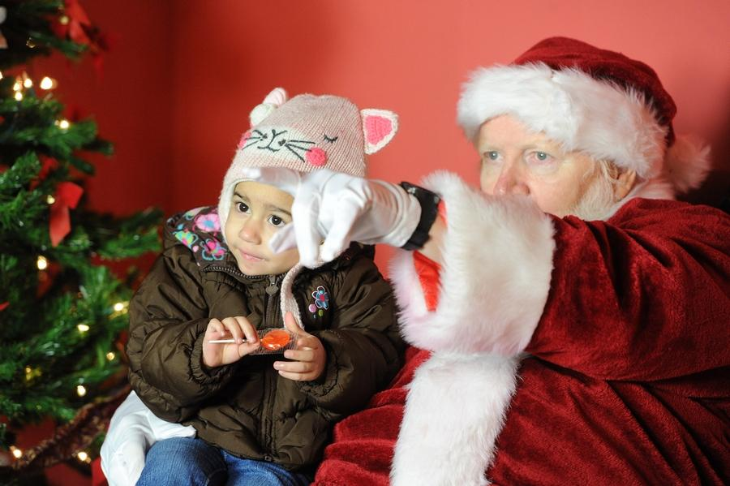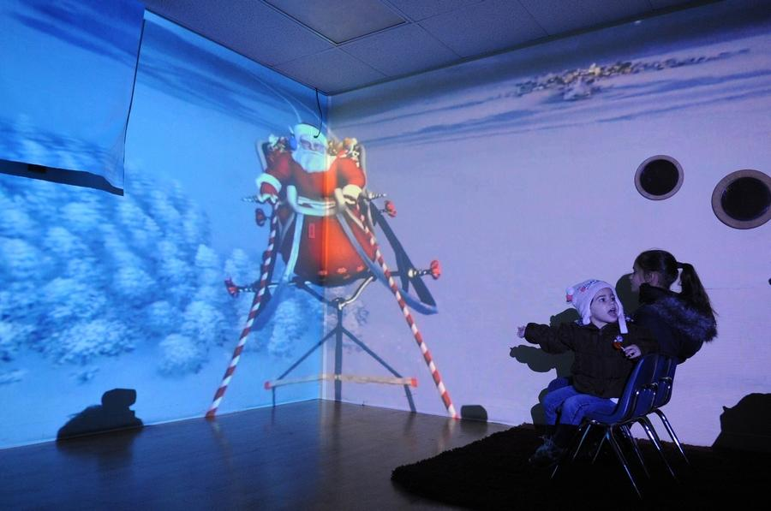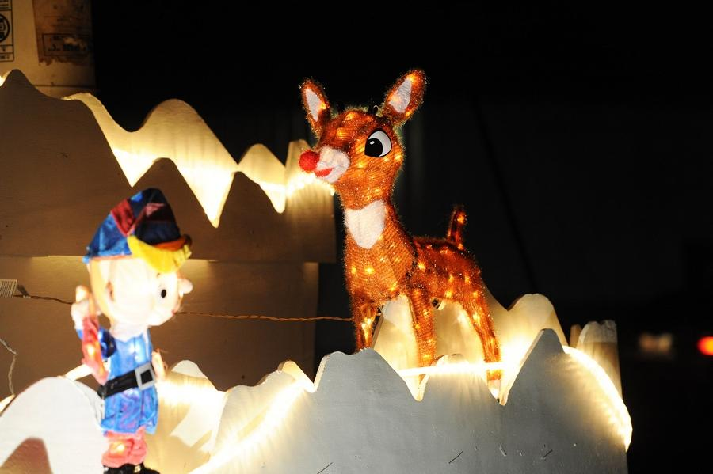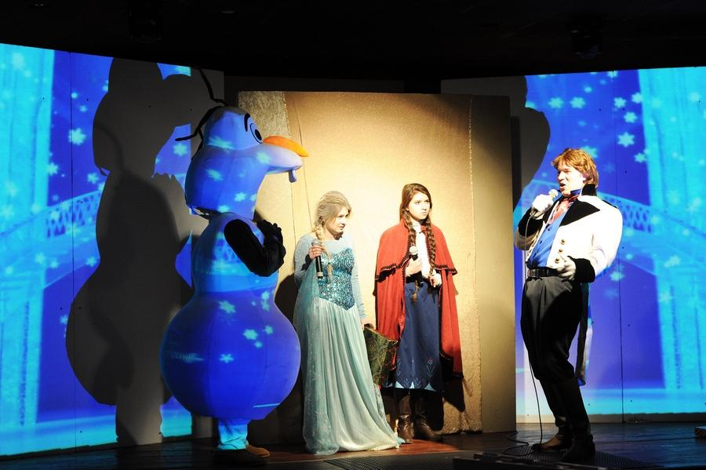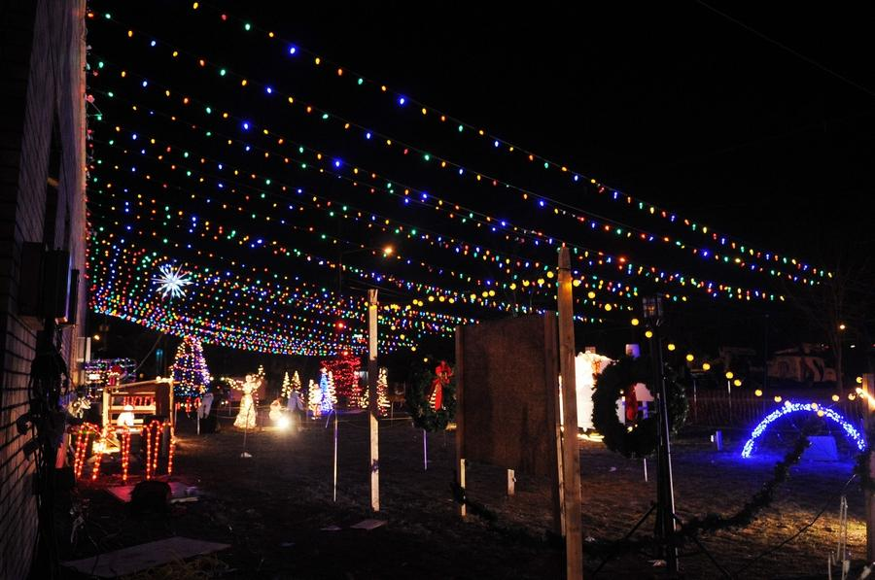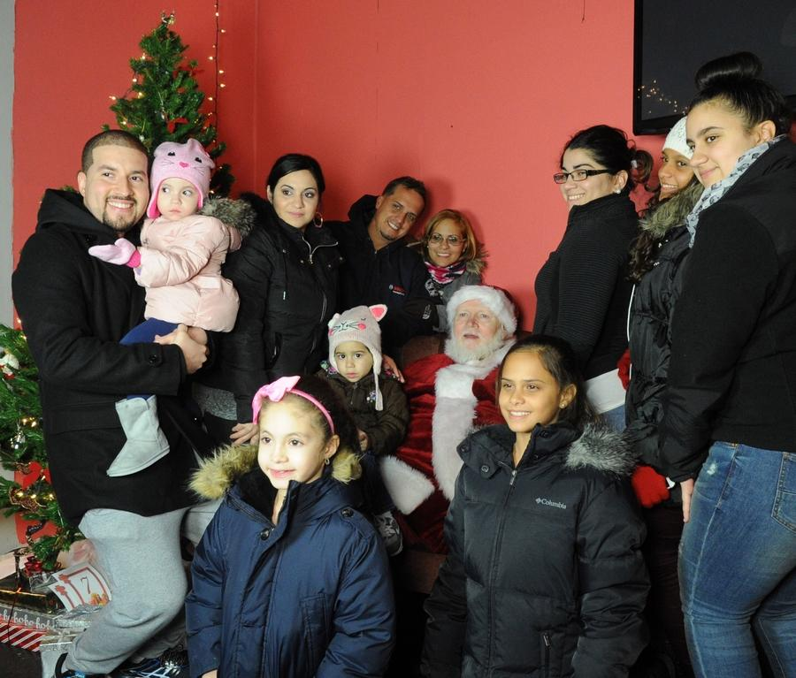

Calendar
Christmas Park will be open on 6pm – 9pm
December 16 – 23rd.
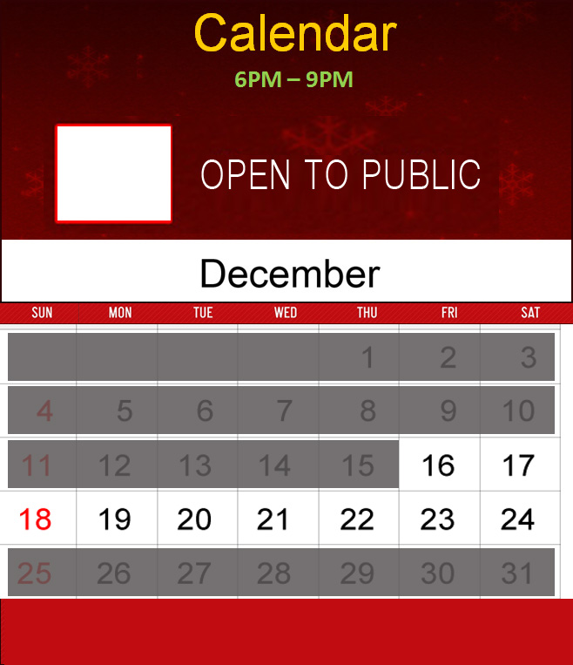

Sponsorship
Event Area Sponsor  You can sponsor a specific part of this event. Your company will be co-branded with the name of the area. Example: Christmas Park brought to you by (Company Name and Logo)  All sponsors in this level will also be recognized in our sponsorship booklet and be recognized on the sponsor’s page of the website.  Two sponsors at this level - $500  One sponsor at this level - $1000  Champion Sponsors  This is limited to two sponsors.  Exposure:  Your company name will be the sole sponsor of Christmas Park OR The Projection Show  You will be mentioned in the on-air TV spots  You will be included in all social media and email blasts  Highlighted in the Nightly Projection Show  Highlighted on the website as a Champion Sponsor  Highlighted in the sponsor booklet  Sponsor Amount - $5,000 | Event Sponsors  This is limited to three sponsors.  Exposure:  Highlighted in the Nightly Projection Show  Highlighted on the website as an Event Sponsor  Highlighted in the sponsor booklet  Sponsor Amount - $2500  Sole Platinum Sponsor  This is limited to one sponsor.  Exposure:  Your company name will be affixed to the Wonder of Christmas logo  - Brought to you by [company name]  You will be the premier sponsor associated with all mentions of the Event Name  You will be mentioned in all media spots, newspaper articles, and event brochures  You will be mentioned in the on-air TV spots  You will be included in all social media and email blasts  Highlighted in the Nightly Projection Show  Highlighted on the website as a Sole Platinum Sponsor  Highlighted in the sponsor booklet  Sponsor Amount - $10,000
Material Donations
If you are not able to become a sponsor you may still have some physical items that we need to create a successful event. Please look over the list.

Grounds and Safety  Snow blowers, shovels, sand, rock salt.  Orange vests, light sticks (flashlights),  portable placards, signage.  Outdoor stand up heaters  Santa and Concert Elements  Ropes and stations for crowd control, a large Santa Chair or two, inside lighted trees, Santa Suits.  Printing and Advertising  Printing for flyers, postcards, large posters, banners, vinyl signage, indoor environmental graphics, volunteer badges, show tickets, sponsor booklets.  Food Items  Cases of canned soda, fruit juice or water. Pre-packaged snacks, chips, candy or treats. Professional food warmers and food presentation displays with Plexiglas barriers. | Christmas Park  Christmas lights (LED if possible), animated figurines, outdoor pre-lit trees. Computer animated lighting system specifically for outdoor shows, sand or gravel for path, wireless outdoor sound system. Extension cords (50ft, 100 ft), wood, lumber, nails, screws, power tools. Volunteers to help assemble the park.  Outdoor Projected Show  Computer laptop, 6k lumen projector, 10k lumen projector or higher. Small outdoor shed, powered speakers, extension cords. Wood, lumber, nails, screws. Volunteers to help assemble the video hut.  Computers  Computer laptops or Ipads for show control.  Volunteers  We need extra volunteers to stand outside and control traffic flow.

Sponsor Sheet
Please fill out as much information as possible. Include any logos or artwork for sponsorship recognition.
Company Information  Company Name:  Contact Name:  Phone:  Email:  Address:  Website:  Comments: | Sponsorship Level  Check off your sponsorship level  Area Sponsor  $⬚$Silver Level - $500  $⬚$Gold Level – $1000  Event Sponsors  This is limited to three sponsors.  $⬚$Sponsor Amount - $2500  Champion Sponsors  This is limited to two sponsors.  $⬚$Sponsor Amount - $5,000  Sole Platinum Sponsor  This is limited to one sponsor.  $⬚$Sponsor Amount - $10,000  Donating Physical Items  $⬚$Please specify items

Thank you!

